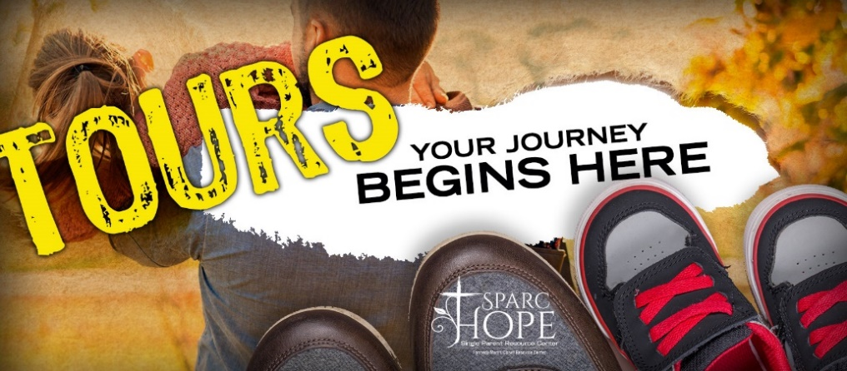

We are excited to offer tours at the Center
to help people learn more about SPARC Hope!

Please join us for a short video,
tour of our In-House Grocery Store,
and speak to one of our Single Parents
about their experience with Sparc Hope.

Please see dates below and let us know
which date works best for you.

Our 2022 dates are sets for:
1/20; 2/17; 3/17; 4/21; 5/19; 6/16;
7/21; 8/18; 9/15; 10/20; 11/17; 12/15

The tours are set from 12 pm – 1pm

Please RSVP in advance at 502-2425-9899 or
www.sparc-hope.org/tours-your-journey-begins-here/

