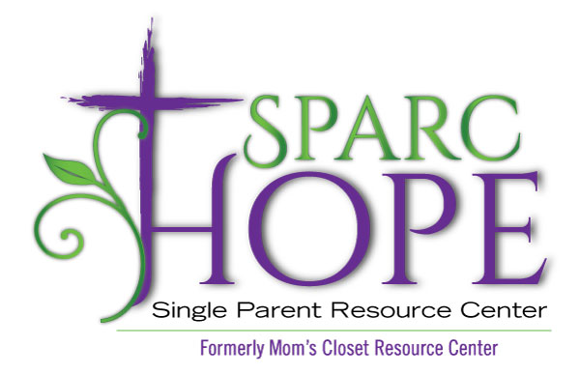
Sparc Hope is supporting 15 families (50 people)
ITEM | Amount we have on shelf
Frozen fruit/ Veggies | 0
Box of Plastic or rubber gloves | 0
Antibacterial wipes | 0
Dairy – Yogurt | 0
Anti- bacterial wipes | 0
Juice | 0
Tylnol/motrin | 0
Toilet Paper | 2 weeks supply
Baby wipes | 2
Paper Towels | ONLY 3 rolls
Hand soap | 3
Canned potatoes/carrots | 3
Parmesan cheese | 4
Salsa/queso | 4
Cooking oil | 4
Coffee | 5
Quart sized bags | 5
Sandwich bags | 5
Gallon sized bags | 5
Sugar | 5
Instant mashed potatoes | 6
Brown rice | 6
Brown sugar | 6
Clean and free Laundry Detergent | 6
Mouth wash | 6
Apple sauce | 8
Rice/pasta sides | 8
Flour | 8
Multi-Surface Cleaner | 6
Canned fruit (peaches, etc.) | 10
Trash bags | 10
Ramen noodles | 10
Nose tissue | 10
Pantry – Food Drives / Pantry Needs List / Pantry Needs 8.5.2020.doc – Revised 8/5/2020

