COME ONE, COME ALL!
BRING A FRIEND TO
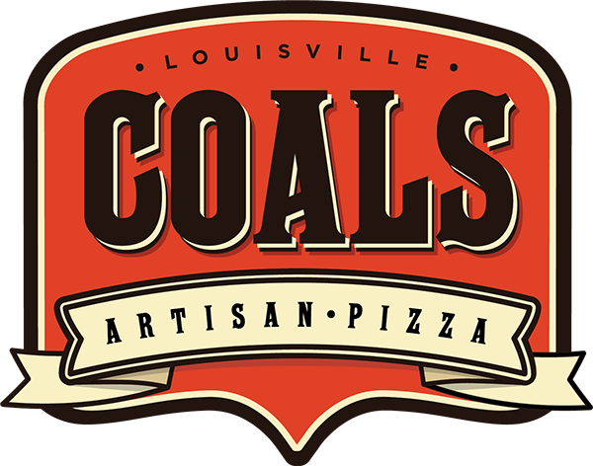
AND EAT FOR
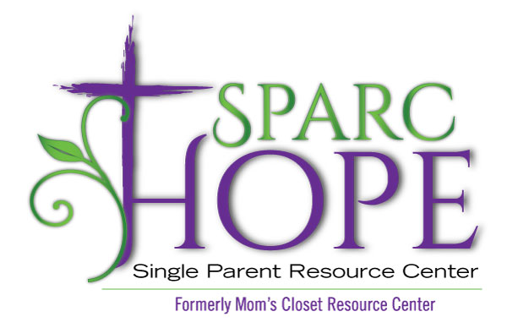
When: Monday, September 16, 2019 from 5pm-9pm
Where: 11615 Shelbyville Rd., Louisville, KY 40243
(502) 253-0106
What to bring: Bring your friends and family to enjoy a delicious meal! Don’t forget to bring flyer to give to your server to support SPARC Hope (formerly Mom’s Closet Resource Center)!
We will be receiving a portion of the proceeds!

Can’t wait to see you there!

