COME ONE, COME ALL!
BRING A FRIEND TO

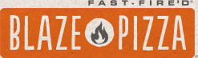
AND EAT FOR
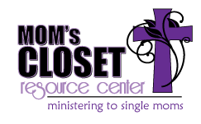
When: Monday, April 15, 2019 from 5-8pm
Where: Blaze Pizza, 13317 Shelbyville Rd., 40223; 502-496-9209
What to bring: Bring your friends and family to enjoy a delicious meal!
Don’t forget to bring this flyer and tell your server you are eating for Mom’s Closet Resource Center!
We will be receiving a portion of the proceeds!

We can’t wait to see you there!

