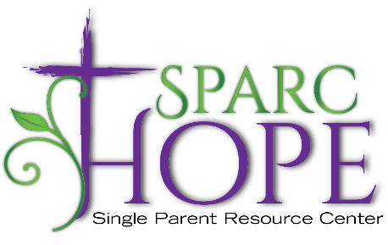
Individual Client Needs List including household items, specialty items, repairs, etc.
(updated 9/10/2021)
Please feel free to contact our office with any questions, 502-245-9899, or email frankie@sparc-hope.org.

Client needs a door put on hinges, or even shaved at top and bottom. (40214 area)
Client needs a new door put on outside? (40214 area)
Client needs new tires for car. Any ideas welcome. Cheapest we could find if approximately $500.

